BIO542: Machine Learning for Biomedical Applications (MLBA)
(8th December 2024, End-sem exam)
Maximum Marks: 60 Duration: 90 Minutes

Name: ________________ Admission No: _____________
Instructions: This question paper have two sections, A and B. Attempt any 14 questions from section A, each question carries 2 marks (Total 28 marks). Attempt any 8 questions from section B, each question carries 4 marks (Total 32 marks). Write all answers in answer sheet only.

Section A
- Name the tool used for genotype imputation and haplotyping using WGS sequence.
Ans: MaCH
- Write formula for standardization
Ans: 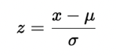

Where:
- z is the standardized value.
- x is the original value.
- μ is the mean of the dataset.
- σ is the standard deviation of the dataset.
- Which feature selection method uses Lasso regularization (Filter, Wrapper, Embedded)
Ans: Embedded method
- In which year, Caenorhabditis elegans has been sequenced and what is its genome size.
Ans: 1998, 97 Mb or 19,000 genes
- Write full form of TCGA and its year of initiation.
Ans: The Cancer Genome Atlas and 2006
- How many drugs and cell lines (information) have been in maintained in CancerDR.
Ans: 148 drugs and 952 cell lines
- Write name of any two boosting techniques.
Ans: AdaBoost, Gradient Boosting, XGBoost, CatBoost, LightGBM
- Write the formula of gini index and entropy?
Ans:
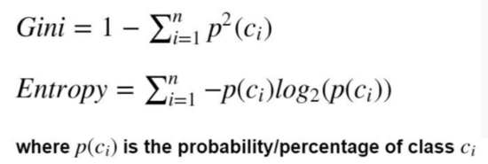
- A bag contains 5 blue balls, what will be entropy and gini index.
Ans:
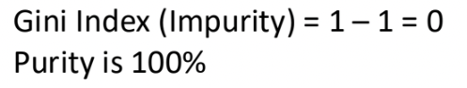
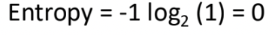
- Write full form of deep learning techniques LSTM and RBM
Ans: Long Short-Term Memory networks, Restricted Boltzmann Machines
- Describe importance of pooling in CNN.
Ans: Pooling reduces the complexity. We can subsample the image to make it smaller and with fewer parameters that can characterize the image.
- Write name of four deep learning frameworks
Ans: TensorFlow, Keras, Pytorch, Theano, DL4J, Caffe, Chainer, Microsoft CNTK
- Write applications of software AC2DGel.
Ans: Analysis and comparison of 2D gels
- Write the full form of any two: SIFT, RIFT, HoG, GLOH.
Ans: SIFT: Scale-invariant feature transform, RIFT: Rotation-invariant feature transform, HoG: Hough transform, GLOH: Gradient Location and Orientation Histogram
- Sort following techniques based on their interpretability (ascending order): RF, ANN, LR, SVM
Ans: ANN, RF, SVM, LR
- What is the full form of LIME and SHAP
Ans: Local Interpretable Model-agnostic Explanations, (SHapley Additive exPlanations)
- List two ML based models come under category of opaque models
Ans: RF, SVM
- Give two examples of rule-based models.
Ans: Decision Tree, Random forest, CART: Classification and Regression Trees)

Section-B

- Show univariate feature selection by flowchart (Input and Output variables are numerical).
Ans:
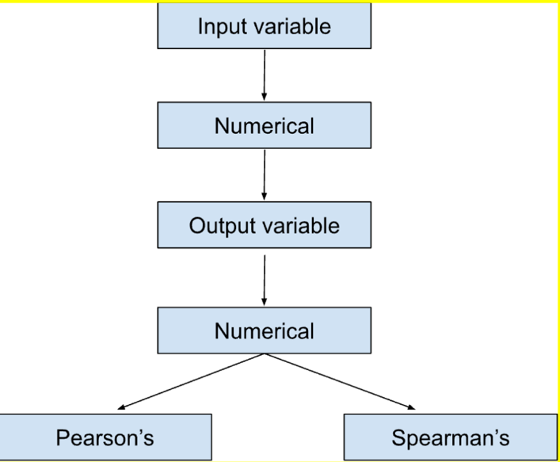

- Describe univariate feature ranking with graph and t-statistics
Ans: Univariate feature ranking is a technique used to evaluate the significance of each feature individually with respect to the target variable. It involves calculating a specific statistical measure for each feature and then ranking them based on their scores. Here it is asked to show it with the t-statistics.
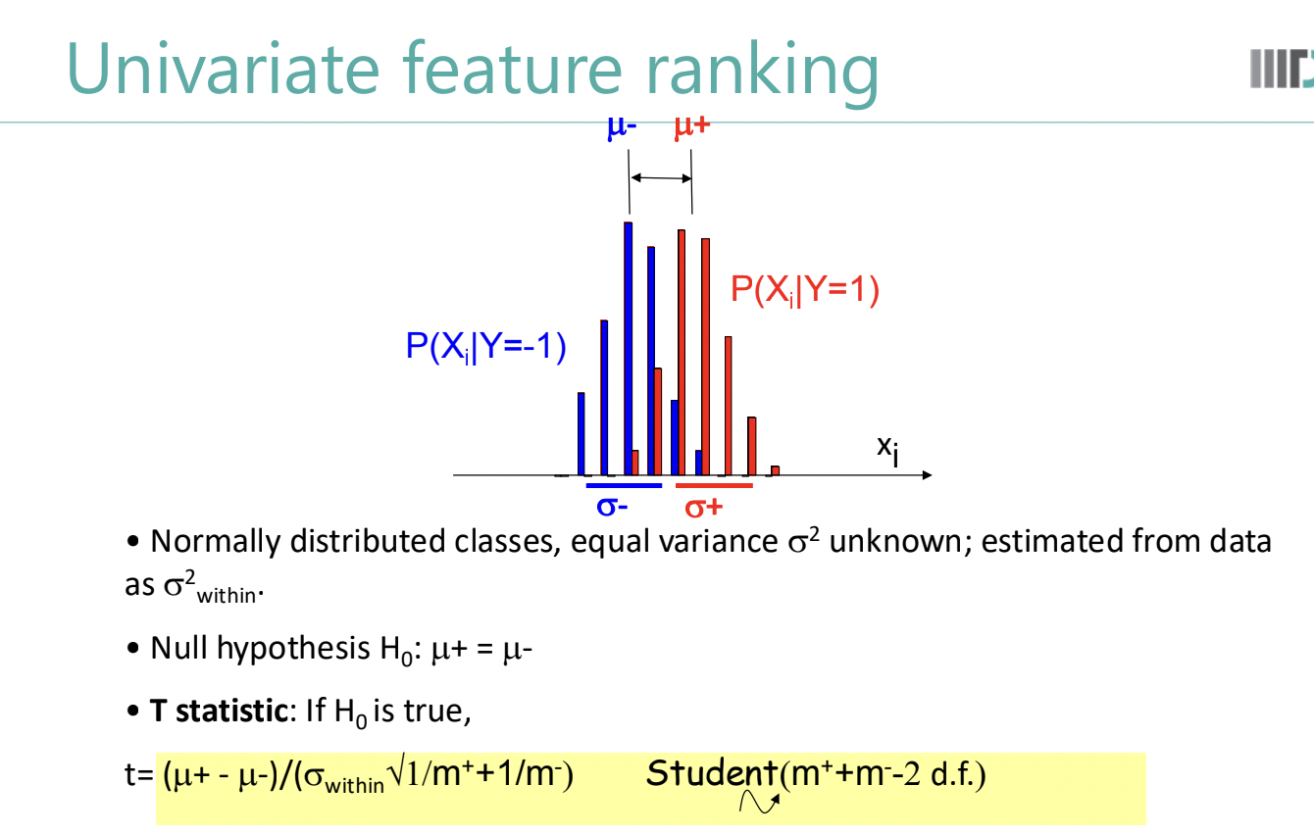
- Draw schematically the Analysis Pipeline of RNA-Seq.

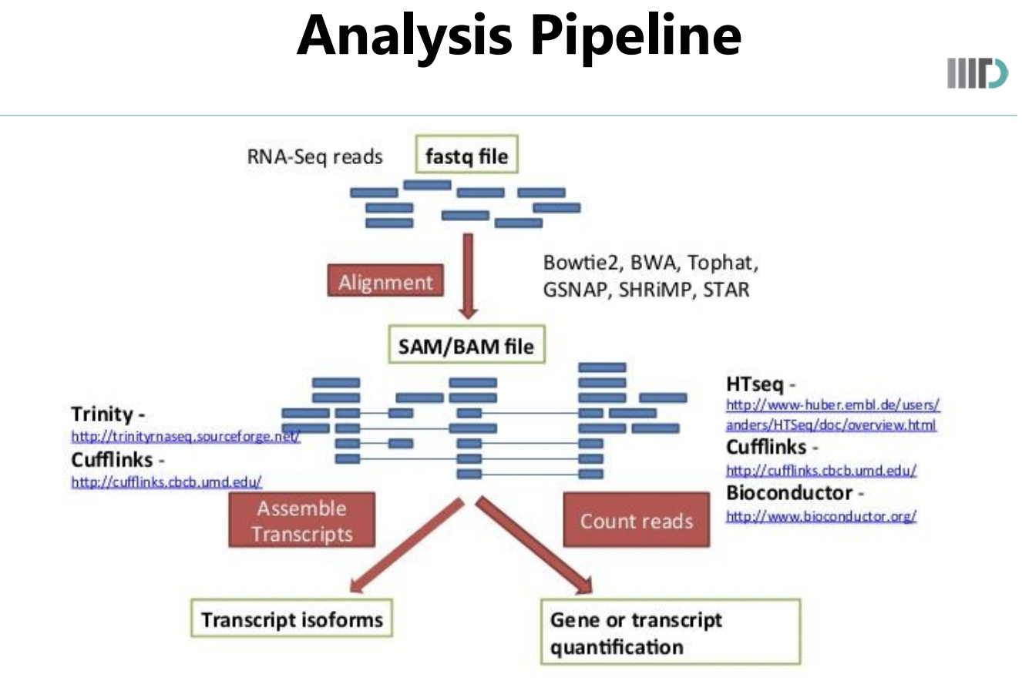

- Write four major steps involved in Random Forest Algorithm.

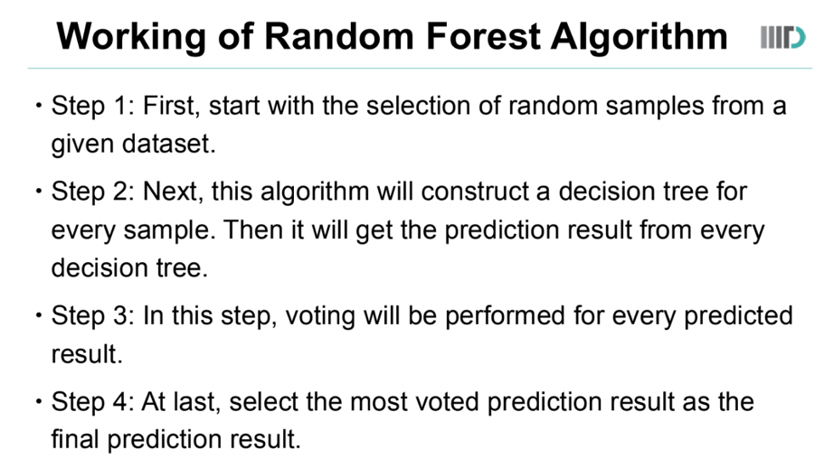
- Briefly describe and compare ID3 and C 4.5 algorithm
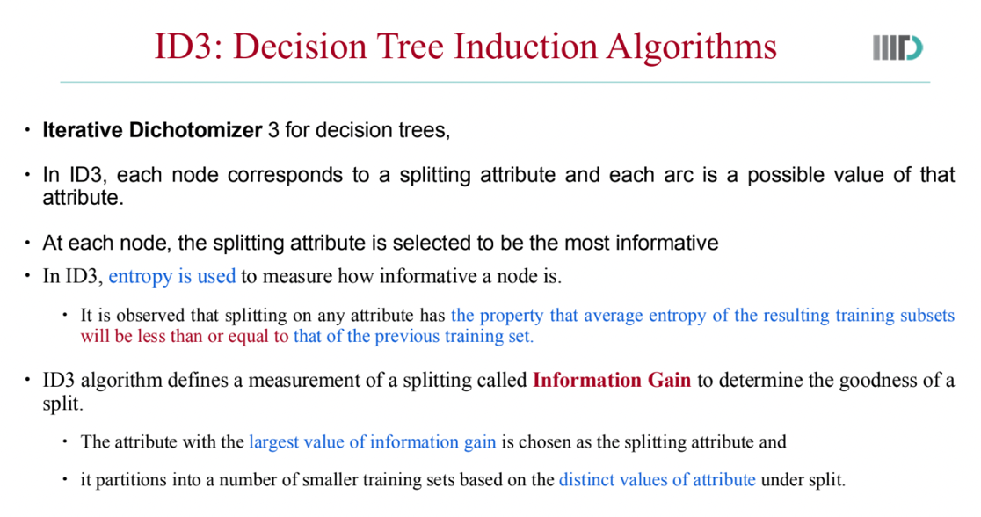

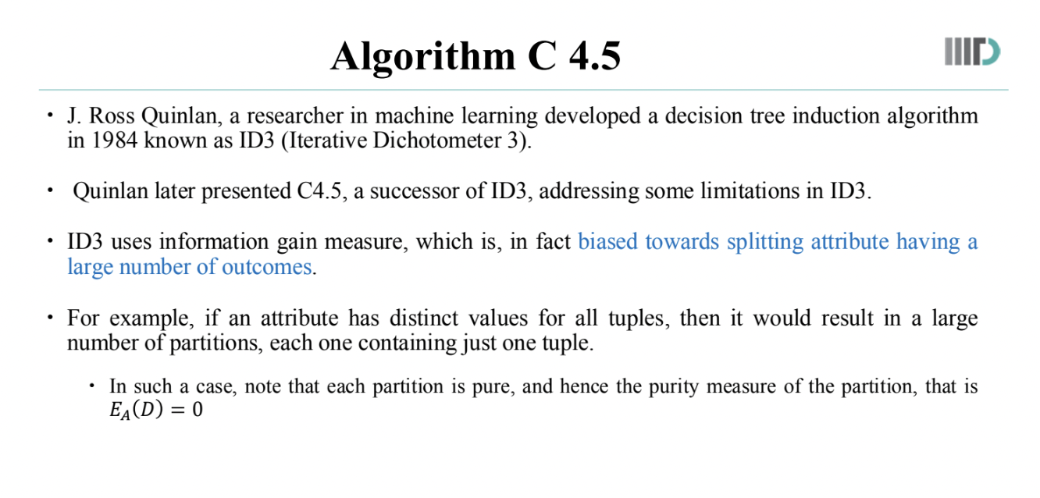
Comparison:
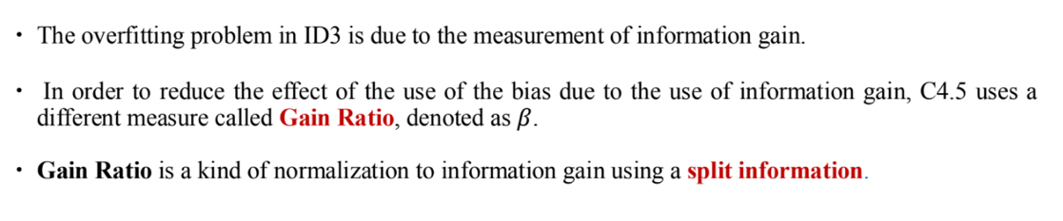

- Show DBN architecture by flowchart, show RBM and hidden layers
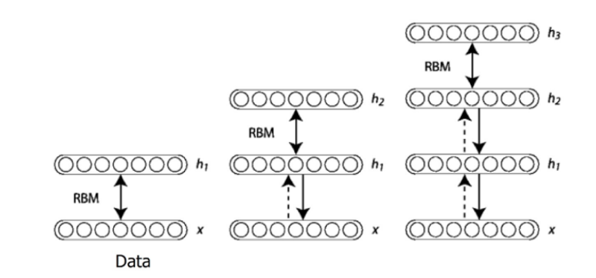

- In CNN, show multiplication of an image matric with a filter

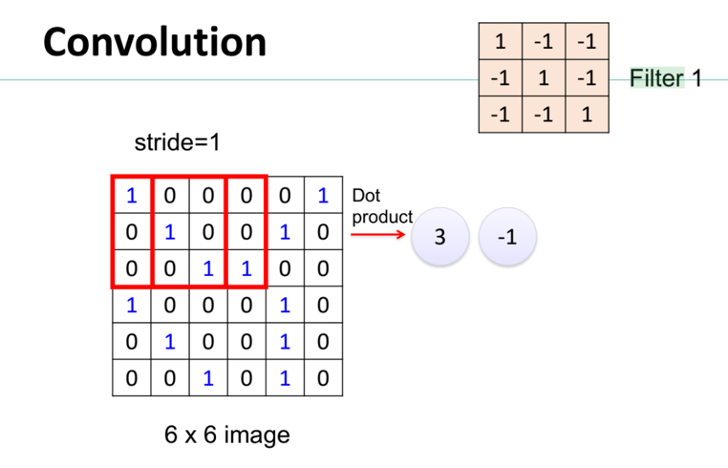
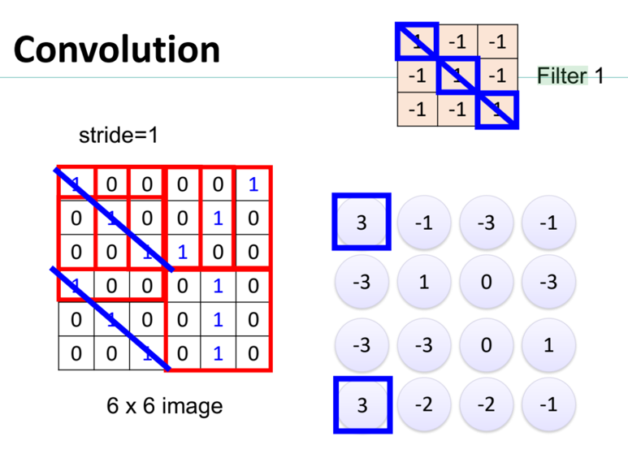
- Explain how SIFT descriptors are computed with steps and vector size.
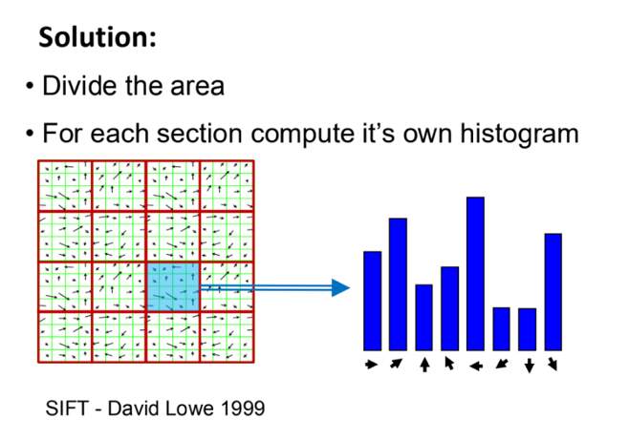
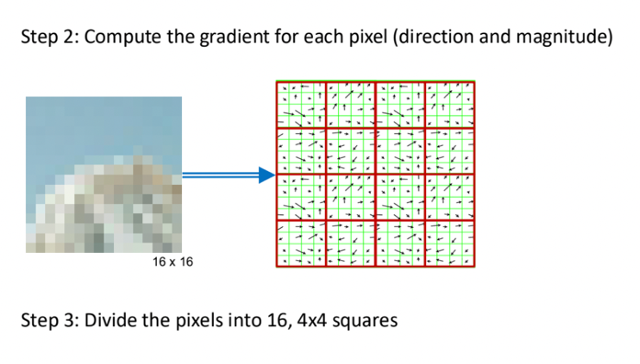
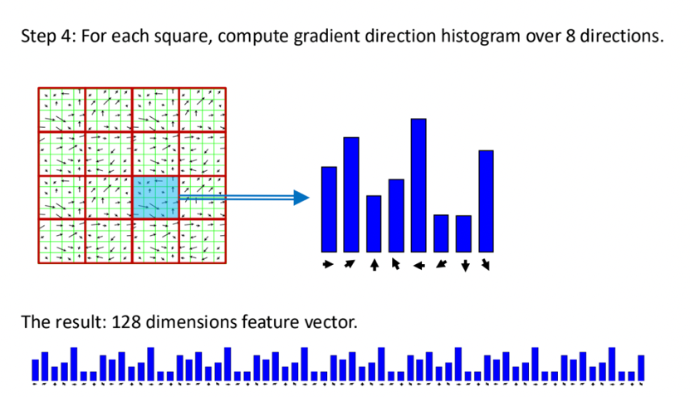

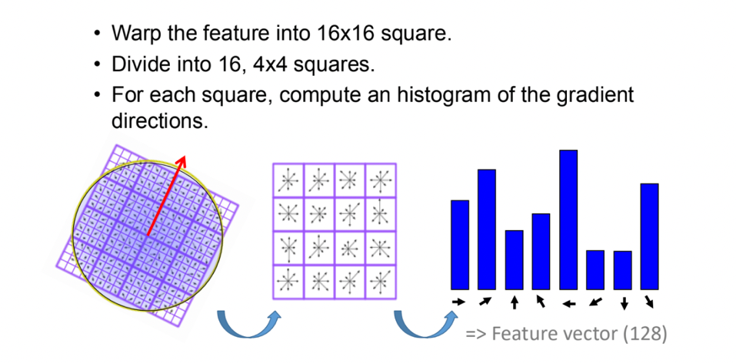
- Write code for computing SIFT descriptors using OpenCV.
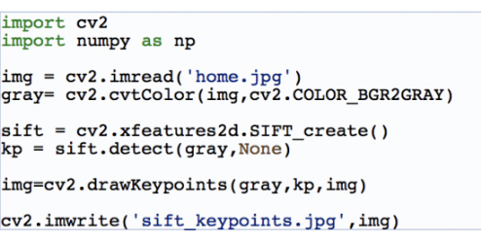

- Show taxonomy of interpretable machine learning methods by flowchart
